6th Form Transition Pack
QUALIFICATION | Applied Certificate/Diploma in Criminology
Teacher Name(s) | Miss O’Brien
Contact email(s) | Diane.o’brien@kingsthorpecollege.org.uk
Exam board and link | WJEC wjec.co.uk
Specification details | 601/6249/1 Applied Certificate  601/6248/X Applied Diploma
WJEC course details | https://www.wjec.co.uk/en/qualifications/criminology-level-3/#tab_overview
Textbooks that are used | 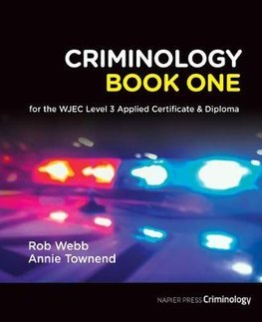  by Rob Webb  published by Napier Press  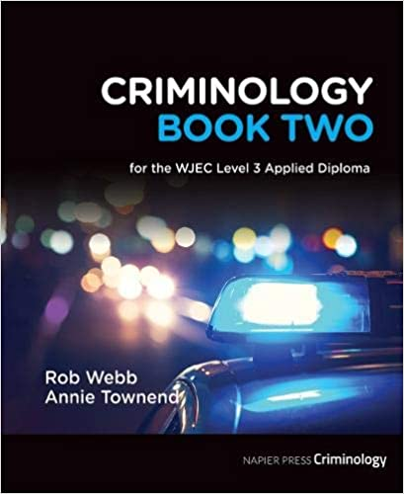  by Rob Webb  published by Napier Press  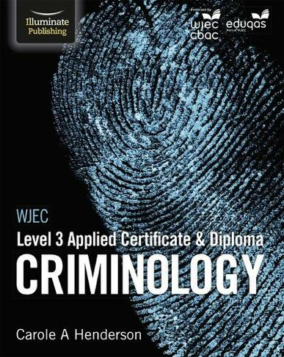  by Carole Henderson  Published by Illuminate  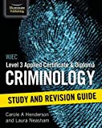  by Carole Henderson  Published by Illuminate

In addition, the transition pack may contain resources like PowerPoints, assessments and activities for you to try at home over the summer.
We recommend you use Cornell Notes to prepare for your new course. Please see this video to help you develop the technique:
https://youtu.be/WtW9IyE04OQ
See the General Transition Pack where VESPA has been outlined for other ways of successfully taking notes and organising the content of your studies effectively.
Please complete the activities in this booklet in readiness to begin your studies when we are told Sixth Form may reopen. This will show us your commitment and may be used alongside your GCSE grades and behaviour log as entry criteria – Sixth Form study is hard work and there are no short cuts. Commitment to your studies is essential.
Good Luck!
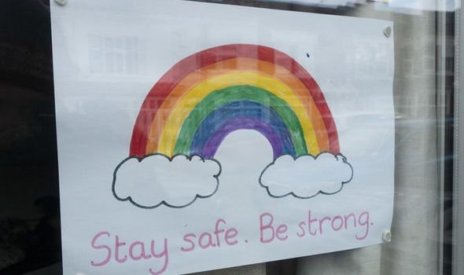

Welcome to Applied Criminology!

You have chosen a subject that combines elements of psychology, law and sociology and that complements studies in humanities. Each unit has an applied purpose which demands that learning is related to authentic case studies – this is the interesting bit! It will certainly ‘keep you on your toes’ and make you think in ways you couldn’t imagine. You will certainly have a very different outlook on society by the end of your course.

Overview of the course:

This is a two-year course. Units 1 and 2 completed in the first year comprise an 8-hour Controlled Assessment plus a formal examination. This is replicated in Year 2 with Units 3 and 4. You must complete and pass ALL units to gain the Diploma. The overall grades will be recorded on a scale A*-E.

Unit 1: Changing Awareness of Crime (Controlled Assessment)
Unit 2: Criminological Theories (Exam)
Unit 3: Crime Scene to Courtroom (Controlled Assessment)
Unit 4: Crime and Punishment (Exam)

Look at the specification for more detail about these topics. You can find this at: https://www.wjec.co.uk/media/21xjkr24/applied-diploma-in-criminology-specification-from-2015.pdf

You will be expected to know and understand the information covered, to be able to apply that knowledge and understanding and to be able to analyse and evaluate that knowledge and understanding.

ESSENTIAL READING

https://www.thebalancecareers.com/what-is-criminology-974589

Task 1

Read the specification carefully and make a note below of the sections there are to each Unit:

Changing Awareness of Crime…………………………………………………………..
.………………………………………………………………………………….………………
………………………………………………………………….............................................
Criminological Theories…………………………..………………………………………...
…………………………………………………………………………………………………..
…………………………………………………………………...……………………………..
Crime Scene to Courtroom………………………………………………………………..
…………………………………………………………………………………………………..
…………………………………………………………………………………………………..
Crime and Punishment in Society………………………………………………………..
………………………………………………………………………………………………….
…………………………………………………………………..………………………………

Expectations of the course:

- Lessons consist of taking notes, group discussions, watching relevant DVDs/documentaries, group work and PowerPoint presentations.
- Homework consists of note making, wider reading, research, past exam questions, power points and essays. It is expected that about 5 hours a week will be spent on Criminology homework.
- The Reading and Watching List on the following page will help you to gain wider knowledge and a broader framework in which to apply your knowledge. You will be expected to choose something to watch/read every half term and to feed back to the rest of the class. You may do this individually, in pairs or groups.
- Your progress will be reviewed on a regular basis. The review process will provide feedback at specific times throughout the year. You will also be expected to be within two grades of your target grade on each piece of work.
- You are expected to use the resources available to you in the library and common room here and are strongly encouraged to use libraries outside of school, not just the internet.
- Make a Criminology chat/whatsapp for discussion.
- Your folders of notes will be checked on a regular basis to see if you are organised and up to date with your work.
- USE YOUR STUDY TIME AND BE PRO-ACTIVE.

Reading List - Criminology
- Closing Ranks, My Life as a Cop – Leroy Logan
- Folk Devils and Moral Panics – Stanley Cohen
- A Glasgow Gang Observed – Patrick James
- Gang Leader For A Day – Sudhir Venkatesh
- Fake Law – The Secret Barrister
- Traces: Memoir of a Forensic Scientist and Criminal Investigator – Patricia Wiltshire
- My Life With Murderers – David Wilson
- A wide range of newspapers including The Guardian and Independent
- Chasing the Scream – Johann Hari
- Are Prisons Obsolete? – Angela Y Davis
- The Executioners Song – Norman Mailer

Watching List - Criminology
- Any documentaries, including Panorama, Louis Theroux, Stacey Dooley, Mind of a Murderer etc
- Black Mirror series (Netflix)
- Goodfellas
- The Godfather (part 2 is the best)
- Legend
- McMafia (previously BBC i-player)
- Freedom Writer’s Diary
- Dangerous Minds
- Chernobyl (drama)
- When They See Us (Netflix)
- The Society (Netflix)
- Blood Diamond
- Ted Talks/Crime/Criminal Justice
- Orange is the New Black (Netflix)
- The Innocence Files (Netflix)
- Cold Case Files (Netflix)
- I Am A Killer (Netflix)
- When They See Us Now – Oprah Winfrey (Netflix)
- The Stanford Prison Experiment (Youtube)
- The Push – Derren Brown (Netflix)
- MacIntyre Undercover: The Chelsea Headhunters (Youtube)
- The Shawshank Redemption
- The Green Mile

Task 2
Choose something from the Reading and Watching List that you are going to report on in your first Criminology lesson (or chose your own)
Task 3
Watch the following clip and jot down 5 things that tell you what Criminology is.

https://www.youtube.com/watch?v=tdaqqlFQdTE
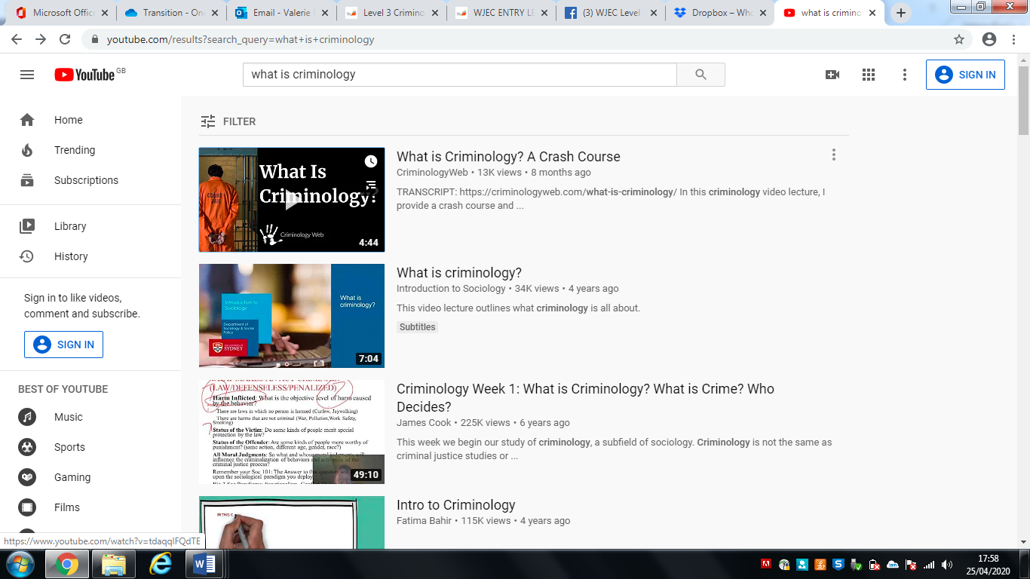



Task 4

What’s the difference between a crime and deviance?

A crime can be defined as ……………………………………………………………….

…………………………………………………………………………………………………..

Deviance is …………………………………………………………………………………..

…………………………………………………………………………………………………..

Examples of crimes are: …………………………………………………………………...

…………………………………………………………………………………………………..

Examples of deviance are: ……………………………………………………………….

…………………………………………………………………………………………………..

Task 5

Think of 3 different ways society has changed over the last 100 years. Try to be specific about the change eg. homosexuality is no longer illegal.

- ……………………………………………………………………………………………..

- ……………………………………………………………………………………………..

- ……………………………………………………………………………………………..

Now, name 3 ways in which British society is different to another (America, Italy etc.)


- ……………………………………………………………………………………………

…………………………………………………………………………

- ……………………………………………………………………..

……………………………………………………………………………

- ……………………………………………………………………………………………

…………………………………………………………………………………………………

Task 6
Research the following types of crime. You need to understand the definition of the type of crime, the typical offender and the typical victim.

- State Crime

Definition……………………………...............................................................................

.......................................................................................................................................

Typical Offender …………………………………………………………………………….

Typical Victim …………………………………………………………………………......

Example: ……………………………………………………………………………………

…………………………………………………………………………………………………

…………………………………………………………………………………………………

…………………………………………………………………………………………………

…………………………………………………………………………………………………

- White Collar Crime

Definition……………………………...............................................................................

.......................................................................................................................................

Typical Offender …………………………………………………………………………….

Typical Victim ………………………………………………………………………….........

Example: ……………………………………………………………………………………...

…………………………………………………………………………………………………

…………………………………………………………………………………………………

…………………………………………………………………………………………………

…………………………………………………………………………………………………

- Moral Crimes

Definition……………………………...............................................................................

.......................................................................................................................................

Typical Offender …………………………………………………………………………….

Typical Victim ………………………………………………………………………….........

Example: ……………………………………………………………………………………...

…………………………………………………………………………………………………..

…………………………………………………………………………………………………..

…………………………………………………………………………………………………

…………………………………………………………………………………………………

- Technological Crimes

Definition……………………………...............................................................................

.......................................................................................................................................

Typical Offender …………………………………………………………………………….

Typical Victim ………………………………………………………………………………

Example: ……………………………………………………………………………………...

…………………………………………………………………………………………………

…………………………………………………………………………………………………

…………………………………………………………………………………………………

…………………………………………………………………………………………………

- Hate Crime

Definition……………………………...............................................................................

.......................................................................................................................................

Typical Offender …………………………………………………………………………….

Typical Victim …………………………………………………………………………......

Example: ……………………………………………………………………………………...

…………………………………………………………………………………………………..

…………………………………………………………………………………………………

…………………………………………………………………………………………………

…………………………………………………………………………………………………

Task 7

As part of your course you will have to look at campaigns that have caused a change in the law. You will also have to plan your own campaign.
Conduct research on the following campaigns. Find out what the original crime was that sparked the campaign; what the aim of the campaign was; what methods were used (eg. TV interviews, advertising, wristbands, petitions, T-shirts etc) and whether the campaign was successful.

Sarah’s Law
The Double Jeopardy Law
Dignity in Dying
Snowdrop Campaign
Slow Down for Bobby
Anti-Foxhunting Campaign

Task 8
Research how the media report crime and the types of crime they report on. Consider differences between local newspapers, national newspapers, tabloids and broadsheets in their reporting of crime when looking at newspapers as a form of media.

Media 1
Name: …………………………………………………………………………………………
Types of crime reported: ………………………………………………………………….
……………………………………………………………………………………………….....
…………………………………………………………………………………………………..
…………………………………………………………………………………………………..
Examples of headlines/language used: ……………………………………………….
…………………………………………………………………………………………………..
…………………………………………………………………………………………………..
…………………………………………………………………………………………………..
Media 2
Name: …………………………………………………………………………………………
Types of crime reported: ………………………………………………………………….
……………………………………………………………………………………………….....
…………………………………………………………………………………………………..
…………………………………………………………………………………………………..
Examples of headlines/language used: ……………………………………………….
…………………………………………………………………………………………………..
…………………………………………………………………………………………………..
…………………………………………………………………………………………………..
Media 3
Name: …………………………………………………………………………………………
Types of crime reported: ………………………………………………………………….
……………………………………………………………………………………………….....
…………………………………………………………………………………………………..
…………………………………………………………………………………………………..
Examples of headlines/language used: ……………………………………………….
…………………………………………………………………………………………………..
…………………………………………………………………………………………………..
…………………………………………………………………………………………………..
Media 4
Name: …………………………………………………………………………………………
Types of crime reported: ………………………………………………………………….
……………………………………………………………………………………………….....
…………………………………………………………………………………………………..
…………………………………………………………………………………………………..
Examples of headlines/language used: ……………………………………………….
…………………………………………………………………………………………………..
…………………………………………………………………………………………………..
…………………………………………………………………………………………………..

Task 9
Go to the Police UK website http://www.police.uk/ type in your local postcode and look at the crimes in the local area. Consider which crimes the police should be focusing their resources.

Nature vs Nurture – The Big Debate
There are many ways of explaining why certain people do things in certain ways. For example, biologists think that people behave as they do because they are controlled by nature. This is known as Nature theory. Humans are compared to animals and seen to act on instinct.
Sociologists believe that people behave as they do because they are taught how to behave. For example, the sociologist Michael Haralambos states, ‘Human beings learn their behavior and use their intelligence whereas animals simply act on instinct.’ This is known as Nurture theory. Nurture means the way you are brought up. It is also a reference to socialization, the lifelong process by which we learn our culture, values, norms and how to behave.

Task 10

Research the childhood backgrounds of any notorious serial murderers such as Fred West or Harold Shipman. The focus should be on life history and not subsequent crimes. Thinking about what you have read about Nature and Nurture, which explanation could account for their criminal behaviour?

Task 11: Essay
This essay is designed to allow you to demonstrate your understanding and writing skills.
You will be assessed on the quality of your written style, the level to which you have understood and can use key concepts, your organisational skills and ability to follow instructions.
Essay title:
To what extent did childhood experiences either indicate developing problems or appear to contribute to the later offending behaviour?
You will need to select a criminal to write about and pay particular attention to what you have read about nature and nurture. Further research will also be required.
Your essay should have:
- Clear paragraphs, an introduction and conclusion
- Accurate spelling, punctuation and full sentences
- Correct use of grammar
- Accurate phrasing
- A discussion of BOTH nature and nurture, explaining which theory best suits the behaviour of the criminal you have chosen to write about.
Your essay should be at least 500 words and hand written.
You should hand in your essay when directed on your return to 6th Form.

Task 18: Key Words
Find out what the following key words mean.
Key Term | Definition
Criminology
Crime

Deviance
Genocide
Nature/Nurture
Decriminalisation
Moral Panic
Norms
Civil Liberties
Statute
Miscarriage of justice

